Orca Whale Sound Sort
This package contains spectrograms of nine whale calls. Your job is to identify three whale calls that belong to the same clan. Remember, clan members use similar sounds to communicate.

Whale Calls From the Same Clan
Spectrogram __________
Spectrogram __________
Spectrogram __________

Spectrogram One
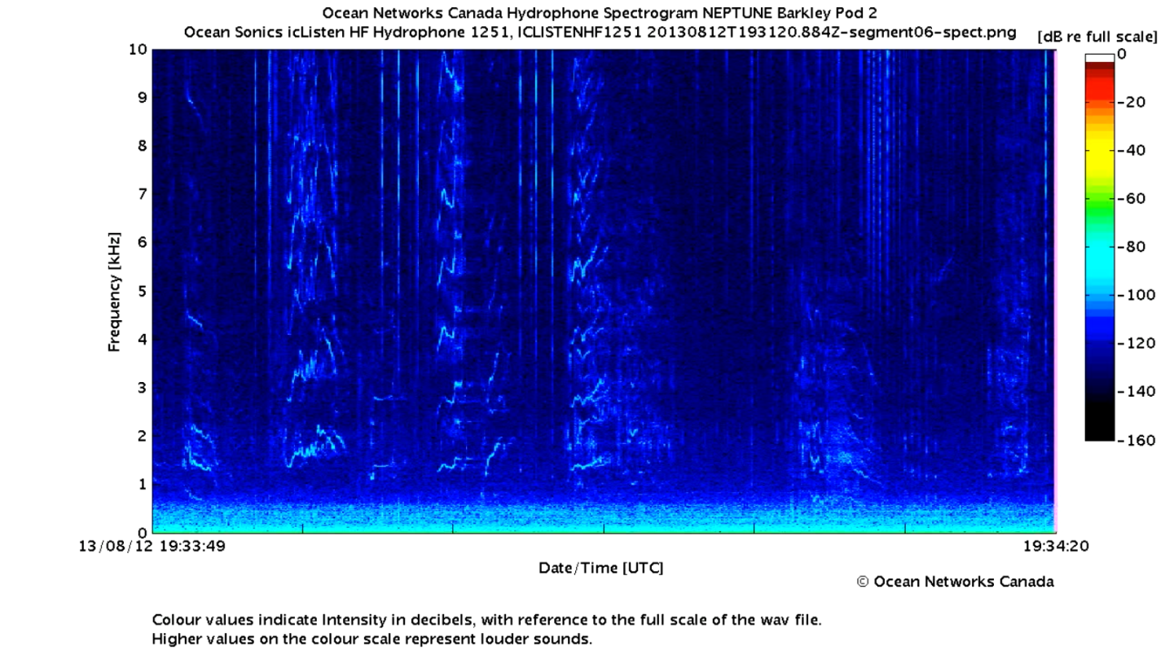

Spectrogram Two
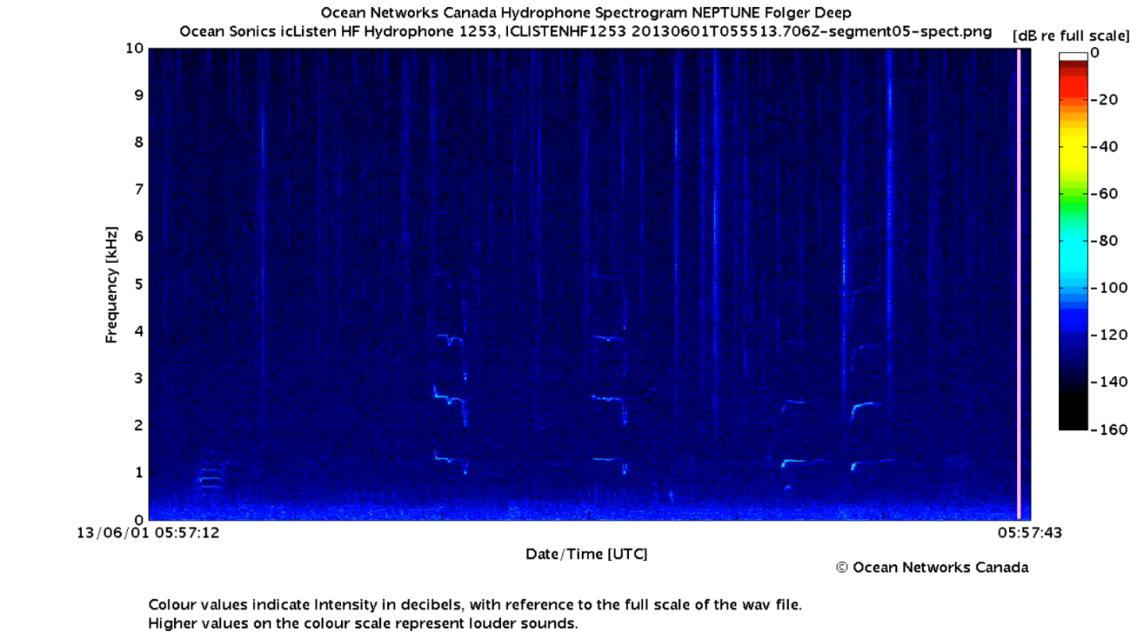

Spectrogram Three
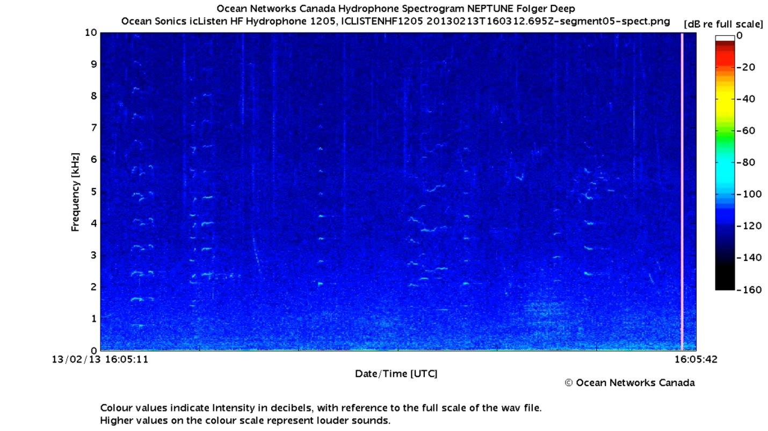

Spectrogram Four
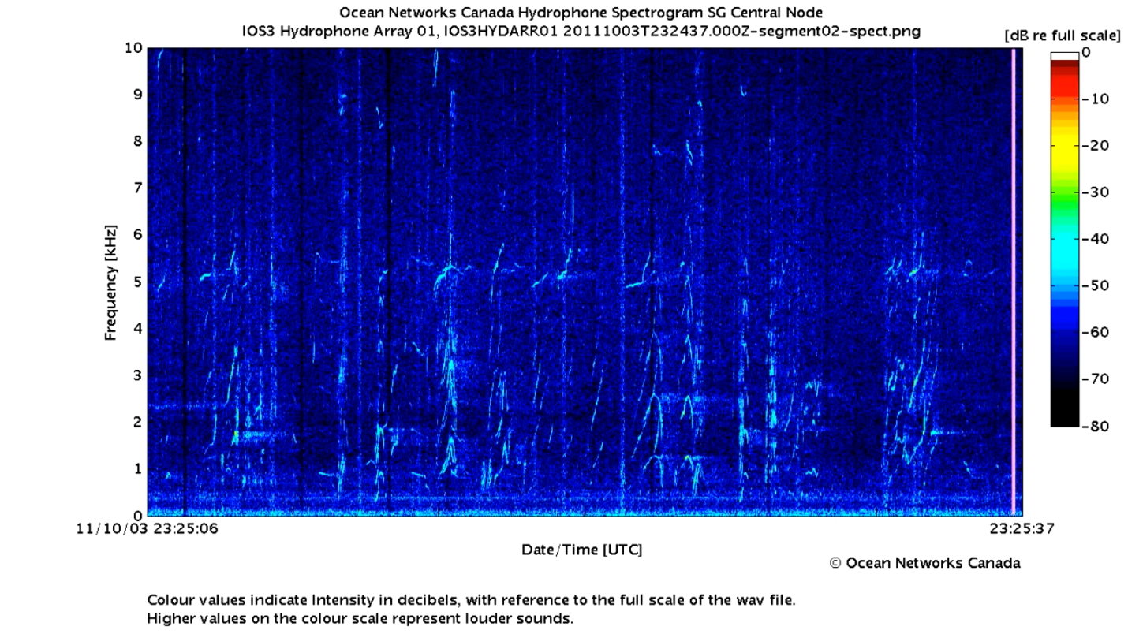

Spectrogram Five
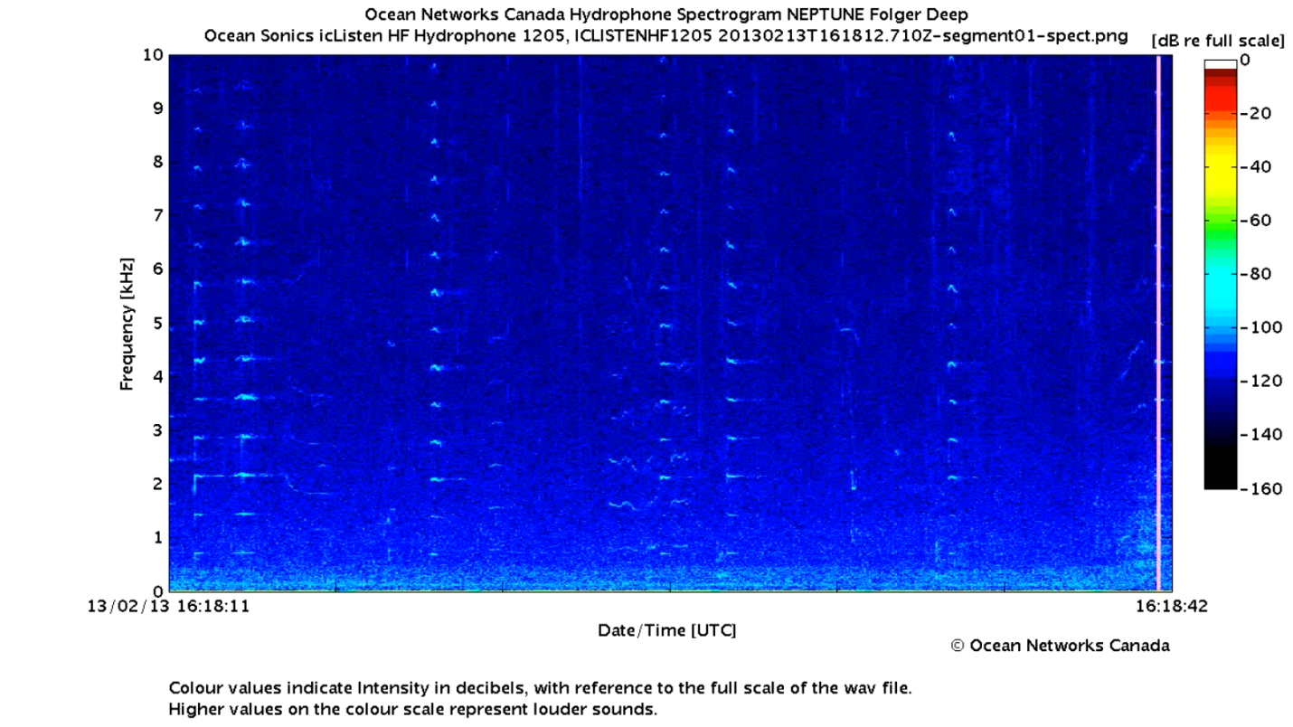

Spectrogram Six
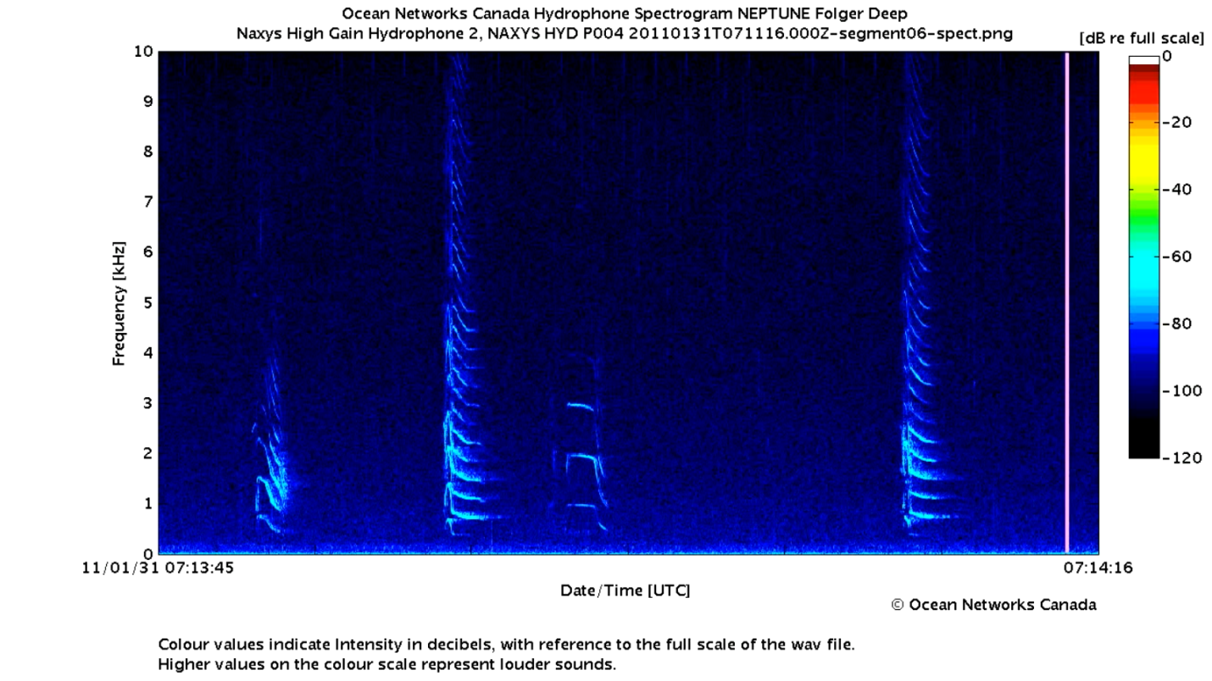

Spectrogram Seven
